Report

|  |  |
| --- | --- |
| **Subject** | Planning Proposal to amend Schedule 1 of the Lismore Local Environmental Plan 2012 to allow an additional permitted use at 163 Invercauld Road, Goonellabah |
| **TRIM Record No** | BP19/1275:AF19/4120 |
| **Prepared by** | Strategic Planning Project Officer |
| **Reason** | To seek a Council resolution to support a Planning Proposal to amend Schedule 1 of the LEP to allow an additional permitted use (function centre) at 163 Invercauld Road, Goonellabah and seek a Gateway Determination from the Department of Planning, Industry and Environment. |
| **Strategic Theme** | Our built environment |
| **Strategy** | Our land-use planning caters for all sectors of the community. |
| **Action** | Ensure a diverse range of land use and development opportunities are available. |

|  |
| --- |
| Executive Summary On 26 September 2019, a draft Planning Proposal was received to amend Schedule 1 of the Lismore Local Environmental Plan 2012 (LEP) to allow an additional permitted use at 163 Invercauld Road, Goonellabah (Lot 22 DP 810042).  The amendment would allow a development application (DA) to be lodged and assessed for a ‘*function centre*’ which is prohibited in Zone R1 General Residential.  Previous approvals have allowed for the development of a range of educational, conference and accommodation facilities at the site. These historic approvals were approved as part of an education establishment and the Planning Proposal is seeking to formalise existing uses and to allow for future non-educational conferences and functions.  An assessment of the site’s constraints has not revealed any impediments that cannot be resolved or the need for further technical reporting.  It is recommended that Council support the attached Planning Proposal and forward it to the Department of Planning, Industry Environment requesting a Gateway Determination. |

*Do not delete this line*

Recommendation

|  |
| --- |
| That Council:   1. Support the Planning Proposal to amend Schedule 1 of the Lismore LEP 2012 as detailed in Attachment 1 of this report to allow an additional permitted use (function centre) at 163 Invercauld Road, Goonellabah, (Lot 22 DP 810042) for the purposes of seeking a Gateway Determination: 2. forward the Planning Proposal to the Department of Planning, Industry and Environment with a request for a Gateway Determination; 3. agree that staff place the Planning Proposal on public exhibition in accordance with a Gateway Determination and report back to Council any issues raised in public submissions and Government Agency comments during public exhibition. |

*Do not delete this line*

Background

On 26 September 2019, a draft Planning Proposal was received to amend Schedule 1 of the Lismore Local Environmental Plan 2012 (LEP) to allow an additional permitted use at 163 Invercauld Road, Goonellabah (Lot 22 DP 810042).

The land is zoned R1 General Residential, and the additional permitted use being sought is a ‘*function centre*’ which is prohibited in the R1 zone. A function centre is defined in the LEP as;

*‘a building or place used for the holding of events, functions, conferences and the like, and includes convention centres, exhibition centres and reception centres, but does not include an entertainment facility’.*

Previous approvals for the land have allowed for the development of a range of educational, conference and accommodation facilities including;

* DA90/323 – Change of use of a dwelling to an educational establishment (comprising staff accommodation, conference and training centre),
* DA93/47 – The erection of 30 multi-purpose student accommodation units and caretaker’s residence ancillary to an existing education / conference centre,
* DA95/100 – Additions to an existing conference and training centre and construction of a 52-space car park,
* DA18/65 – Change of use of manager’s residence to a break-out building associated with conference functions.

These approvals from 1990-95 were approved as an “*education establishment*”. Despite reference to a “conference centre”, this was not defined within the planning instruments at the time and therefore the use is considered to be part of the “*education establishment*”. The student accommodation is also approved as ancillary to the “*education establishment*”.

The approval of the Planning Proposal to permit a ‘*function centre*’ on the subject land in Schedule 1 of the LEP would allow Council to assess and determine a development application to use the site for the purpose of non-educational conferences and functions.

Characteristics and constraints of the subject site

The site is located in a residential area approximately six kilometres by road from the Lismore CBD. It has an area of 2.18 hectares. Surrounding land uses include residential dwellings to the north-east and north-west, with vacant land approved for future residential development in all other directions.

Vegetation on the land consists primarily of maintained and landscaped grounds with mowed grasslands to the north of the main building. A mix of introduced and native vegetation is located along the eastern and western property boundaries. A previous development application (DA18/65) approved the removal of several trees with a condition of consent requiring a vegetation management plan (VMP) for the planting of 25 native rainforest trees and 5 koala food trees within the site.

The site is mapped as containing koala habitat at the southern end; however, an ecological report for the site undertaken in 2018 as part of DA18/65 found no evidence of koala use or any koala feed trees within the site. The report assessed the site’s potential to provide habitat for significant fauna including threatened species. It found there was “*marginal habitat for native fauna and may be used as forage habitat by frugivorous fauna including birds, flying-foxes and microchiropteran bats*.” It also identified ringtail and common possums are likely to be present.

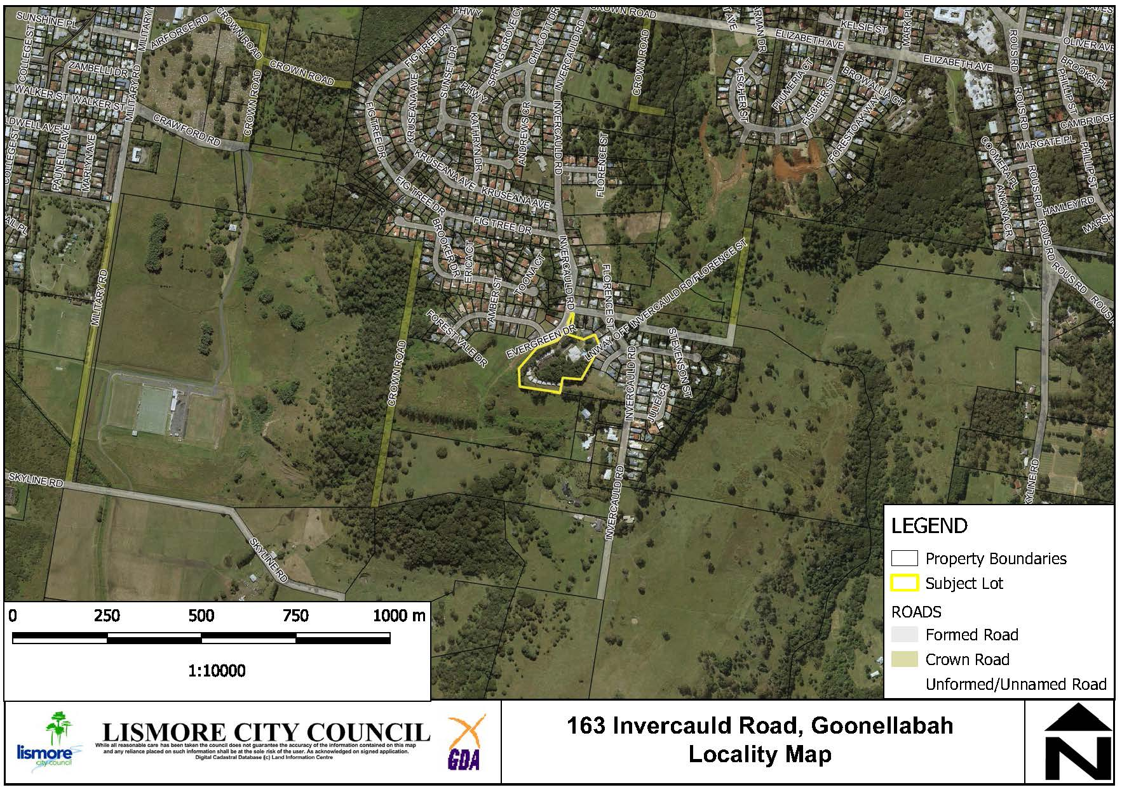

**Figure 1: Subject site and locality.**

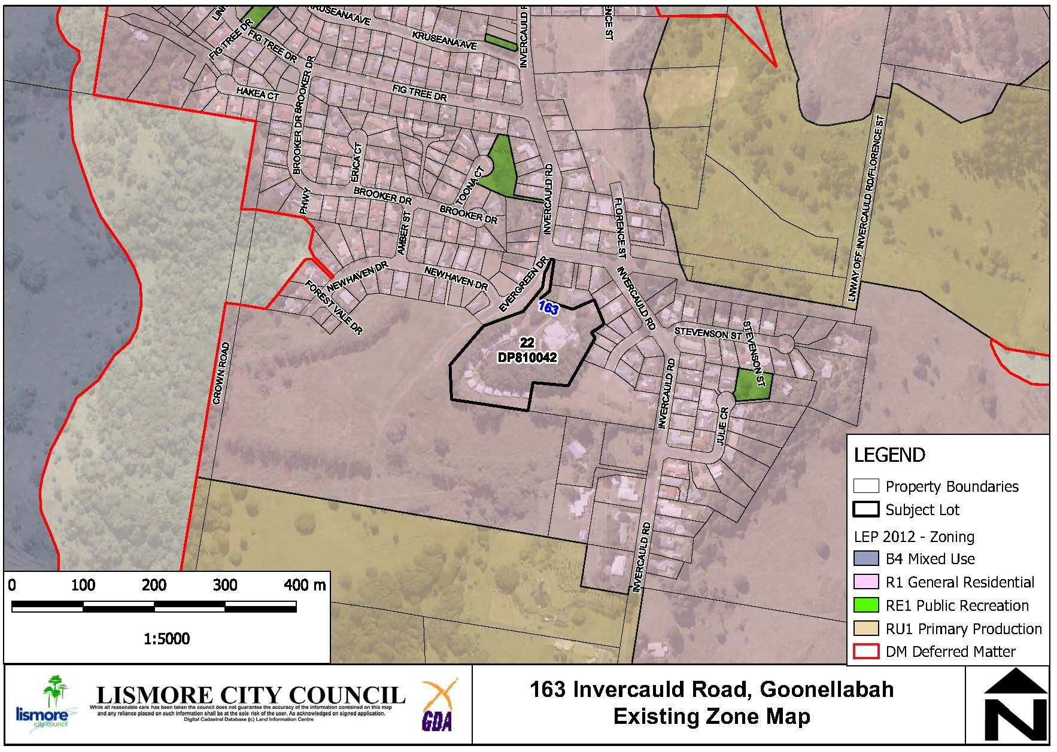

**Figure 2: Location and LEP zoning of 163 Invercauld Road, Goonellabah and surrounding properties.**

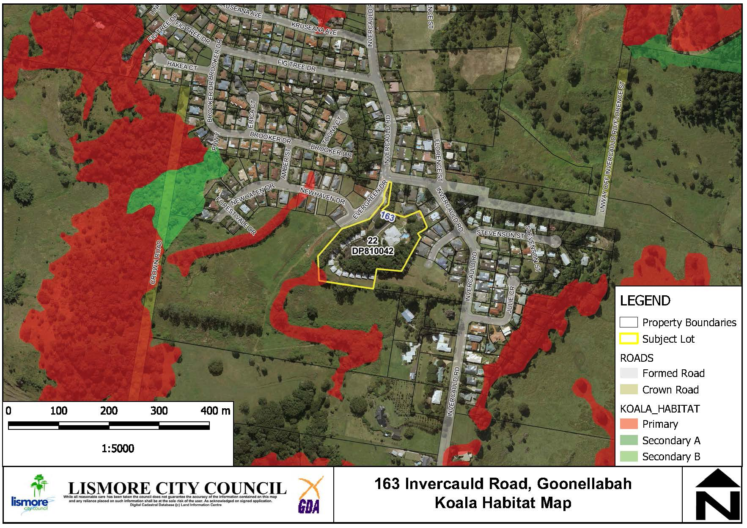

**Figure 3: Koala habitat within and surrounding the subject site.**

The site is also mapped as containing Category 1 bushfire vegetation.

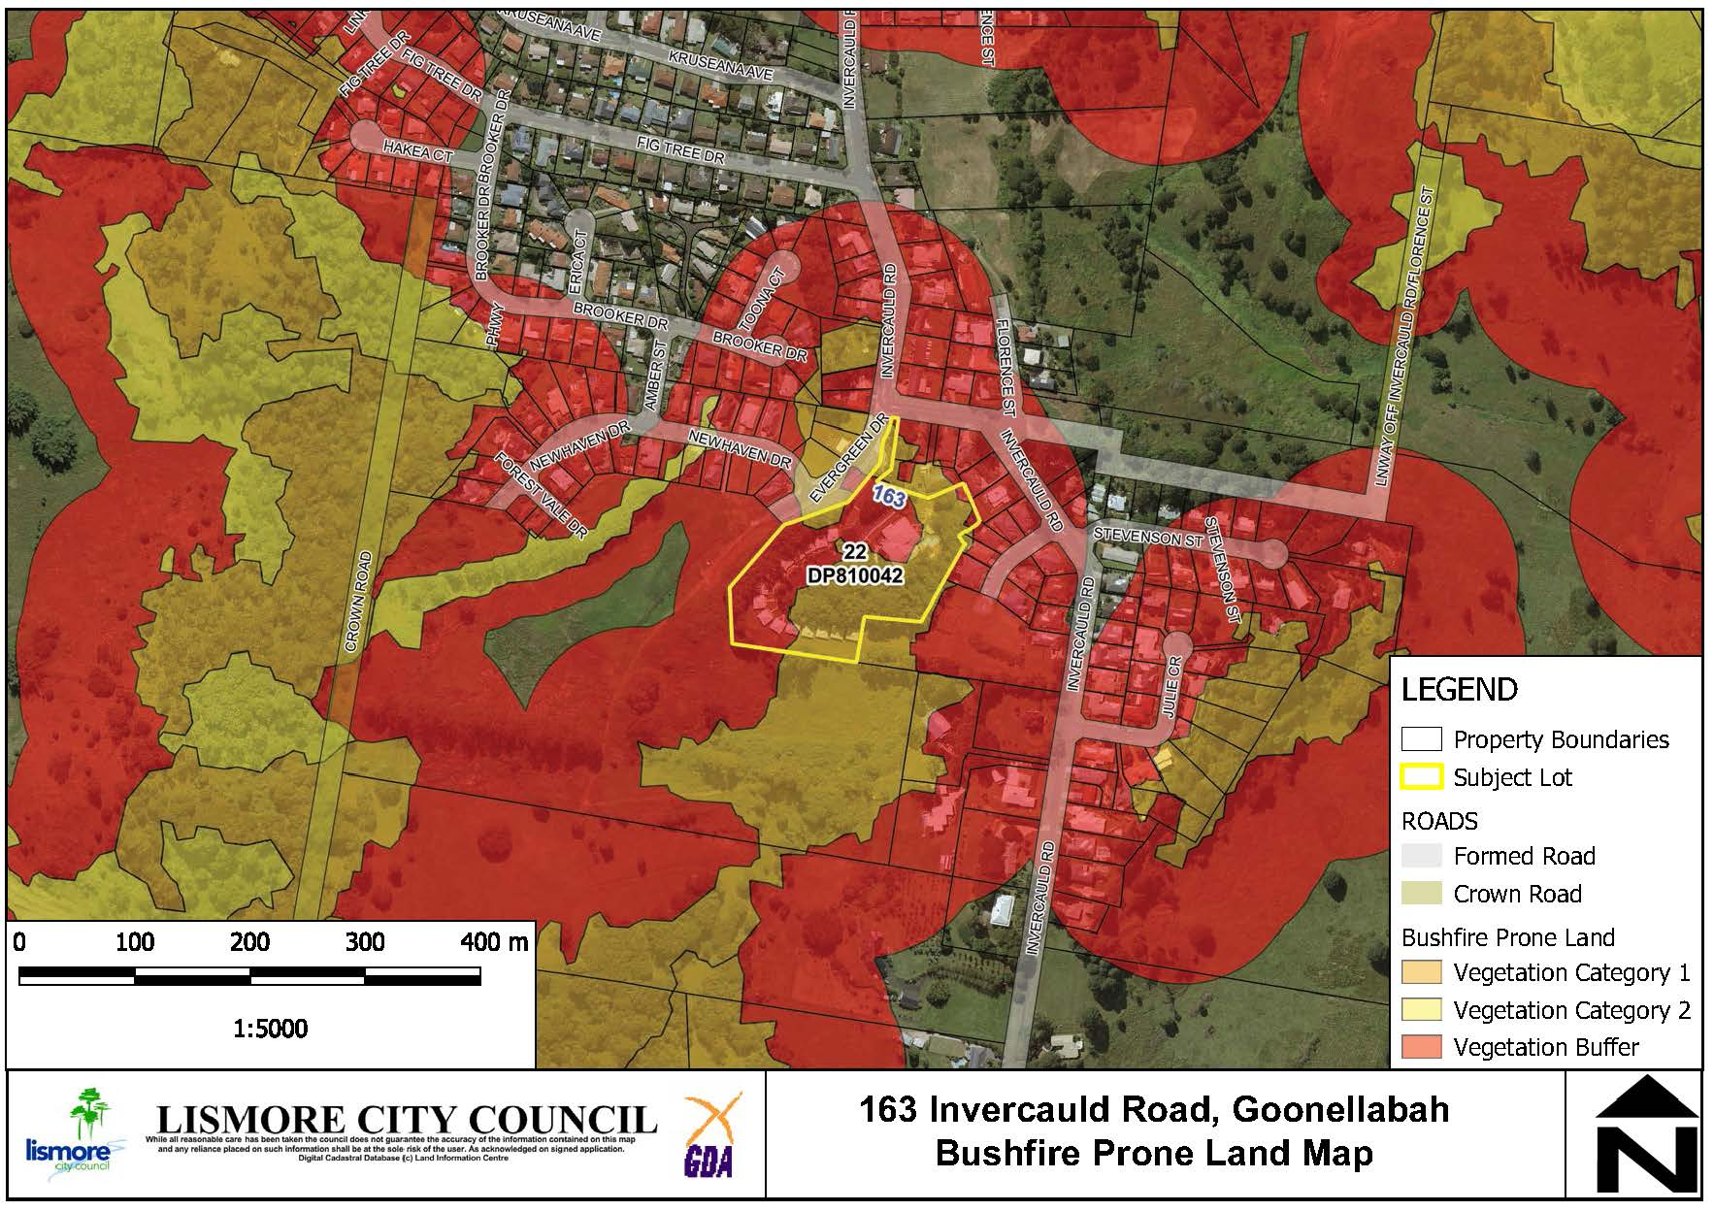

**Figure 4: Bushfire prone vegetation mapping.**

Environmental, Social and Economic Impact Assessment

**Land Use Conflict (Noise)**

The proposed land use has the potential to negatively impact upon neighbours’ amenity. Council’s Environmental Health staff has commented that functions held in the evening and at night are most likely to create noise issues but is satisfied that the issues can be effectively managed through appropriate conditions with any subsequent development application. A Noise Management Plan (based upon acoustic reporting) would be required with any future development application. If the Planning Proposal is supported, adjoining neighbours will be notified and any submissions considered post-Gateway Determination.

**Bushfire Hazard**

The site is mapped as being bushfire prone (as shown in Figure 4). The use of the site as a function centre does not trigger integrated development approval requirements, and therefore referral to the Rural Fire Service, under Section 100B of the *Rural Fires Act 1997*. There will be no change to the building classification (9b) and no external building works. It is recommended that the Planning Proposal is referred to the Rural Fire Service for comment.

**Economic Impact**

The Planning Proposal will not adversely impact upon existing commercial land and will facilitate a greater range of commercial activity within an existing conference / training facility. The result is likely to be additional casual employment opportunities and a positive economic flow-on to local suppliers.

**Aboriginal and European Cultural Heritage**

An AHIMS search was undertaken and no Aboriginal sites or places were identified within 50 metres of the subject land. The land is also not listed as a heritage item in Schedule 5 of the Lismore LEP 2012.

Servicing and infrastructure

Suitable road access is available via Evergreen Drive and the existing road network is sufficient for any increase in vehicle movements. No additional serving is proposed or required.

Overview of the Planning Proposal

The Planning Proposal seeks to amend the LEP written instrument as follows:

* Amend **Schedule 1 Additional Permitted Uses** of the Lismore LEP 2012 to permit additional uses at 163 Invercauld Road, Goonellabah (Lot 22 DP810042). The proposed insertion is:

1. ***Use of certain land at 163 Invercauld Road, Goonellabah***
2. *This clause applies to land at 163 Invercauld Road, Goonellabah (Lot 22 DP 810042) and identified as “Item 8” on the Additional Permitted Use Map.*
3. *Development for the purpose of a Function Centre is permitted with development consent on the land to which this clause applies.*

The following Map sheet is proposed for amendment:

* Additional Permitted Uses Map to identify 163 Invercauld Road, Goonellabah (Lot 22, DP810042) as Item 8.

Table 1 provides a summary of the planning proposal.

**Table 1: Summary of Planning Proposal**

| **PART** | **REQUIREMENTS** | **DESCRIPTION OF PLANNING PROPOSAL** |
| --- | --- | --- |
| 1 | **OBJECTIVES OR INTENDED OUTCOMES** | The objective of the planning proposal is to allow for an additional permitted use at 163 Invercauld Road, Goonellabah (Lot 22 DP 810042) |
| 2 | **EXPLANATION OF PROVISIONS** | The planning proposal seeks to amend the following parts of the Lismore LEP 2012:   * Additional Permitted Uses Map to identify 163 Invercauld Road, Goonellabah as Item 8. * Amend Schedule 1 Additional Permitted Uses of the Lismore LEP to allow additional permitted uses at 163 Invercauld Road, Goonellabah (Lot 22 DP 810042) |
| 3 | **JUSTIFICATION**  **Section A- Need for the Planning Proposal**  ***Is the planning proposal a result of any strategic study or report?***  ***Is the planning proposal the best means of achieving the objectives or intended outcomes, or is there a better way?*** | The Planning Proposal to amend Schedule 1 Additional Permitted Uses of the Lismore LEP 2012 is the most practical method of achieving the aim of enabling the further development of the site for a function centre that is currently prohibited in Zone R1 General Residential.  The planning proposal is not the result of any strategic study or report. The Planning proposal seeks to formalise the historic use of the land and to provide an adaptive reuse of an existing facility. |
| 4 | **JUSTIFICATION**  **Section B- Relationship to Strategic Planning Framework**  ***Is the Planning Proposal consistent with the objectives and actions contained within the applicable regional or sub-regional strategy?***  ***Is the Planning Proposal consistent with the Council’s local strategy or other local strategic plan?***  ***Is the Planning Proposal consistent with applicable State Environmental Planning Policies (SEPP)?***  ***Is the Planning Proposal consistent with applicable s9.1 Ministerial Directions?*** | While the subject site is not identified as an investigation area for employment land in the North Coast Regional Plan (NCRP) 2036, this Planning Proposal reinforces the following directions:  **Direction 6: Develop successful centres of employment –** the Planning Proposal will permit a development application to be lodged for an extension of the existing educational and accommodation uses on the site, providing further economic stimulus during times when the building is not utilised for training and conferences purposes. The proposal will not displace or adversely impact identified employment lands.  **Direction 20: Maintain the region’s distinctive built character –** the Planning Proposal relates to the adaptive use of an existing facility and no additional buildings are proposed or changes to the existing architectural form.  This Planning Proposal responds to the development industry’s need to consider a land use activity that is currently prohibited on land zoned R1 by the LEP 2012 but is considered to be a suitable extension of the existing use.  The planning proposal is consistent with the Lismore City Council Delivery Program 2017 - 2021 Strategy “Ensure a diverse range of land use and development opportunities are available”.  This proposal is consistent with the relevant SEPP’s as outlined in Attachment 1.  This proposal is consistent, or any inconsistency can be justified with applicable s9.1 Ministerial Directions as outlined in Attachment 1. |
| 5 | **JUSTIFICATION**  **Section C- Environment, Social and Economic Impact**  ***Is there any likelihood that critical habitat of threatened species, populations or ecological communities or their habitats, will be adversely affected as a result of the proposal?***  ***Are there any likely environmental effects as a result of the Planning Proposal and how are they proposed to be managed?***  ***Has the Planning Proposal adequately addressed any social and economic effects?*** | The site is mapped as containing koala habitat at the southern end; however, a 2018 ecological assessment found no evidence of koala use and no koala food trees at the site. No additional building works or vegetation removal are proposed as a result of the Planning Proposal and no adverse impacts on habitat for threatened species or ecological communities is expected.  A search of the Aboriginal Heritage Information Management System (AHIMS) was undertaken and did not identify any Aboriginal sites or places on the subject land. The land is also not subject to any listings of environmental heritage items or archaeological sites pursuant to Schedule 5 of the LEP 2012.  With regard to economic impacts, the proposal is likely to increase the opportunities for casual employment and have a positive flow-on effect to local suppliers. |
| 6 | **JUSTIFICATION**  **Section D - State and Commonwealth Interests**  ***Is there adequate public infrastructure for the Planning Proposal?***  ***What are the views of State and Commonwealth public authorities consulted in accordance with the Gateway Determination?*** | The existing road network is sufficient to cater for any additional traffic movements generated by the proposed activity. No other additional services are required.  It is proposed that the Planning Proposal is referred to the Rural Fire Service prior to public exhibition of the Planning Proposal. |
| 7 | **MAPPING** | It is proposed to add an Additional Permitted Uses (APU) Map to identify 163 Invercauld Road, Goonellabah as Item 8 as shown in Figure 4. |
| 8 | **COMMUNITY CONSULTATION** | A 14-day community consultation period is recommended but this will be confirmed in the Gateway determination. |
| 9 | **PROJECT TIMELINE** | Recommendation of approximately 9 months to complete.  Refer to Attachment 1 for detail. |
| 10 | **DELEGATIONS** | Recommendation for Council to exercise plan making delegations. |

Local Environmental Plan Map

The proposed LEP map is shown in Figure 4 below.

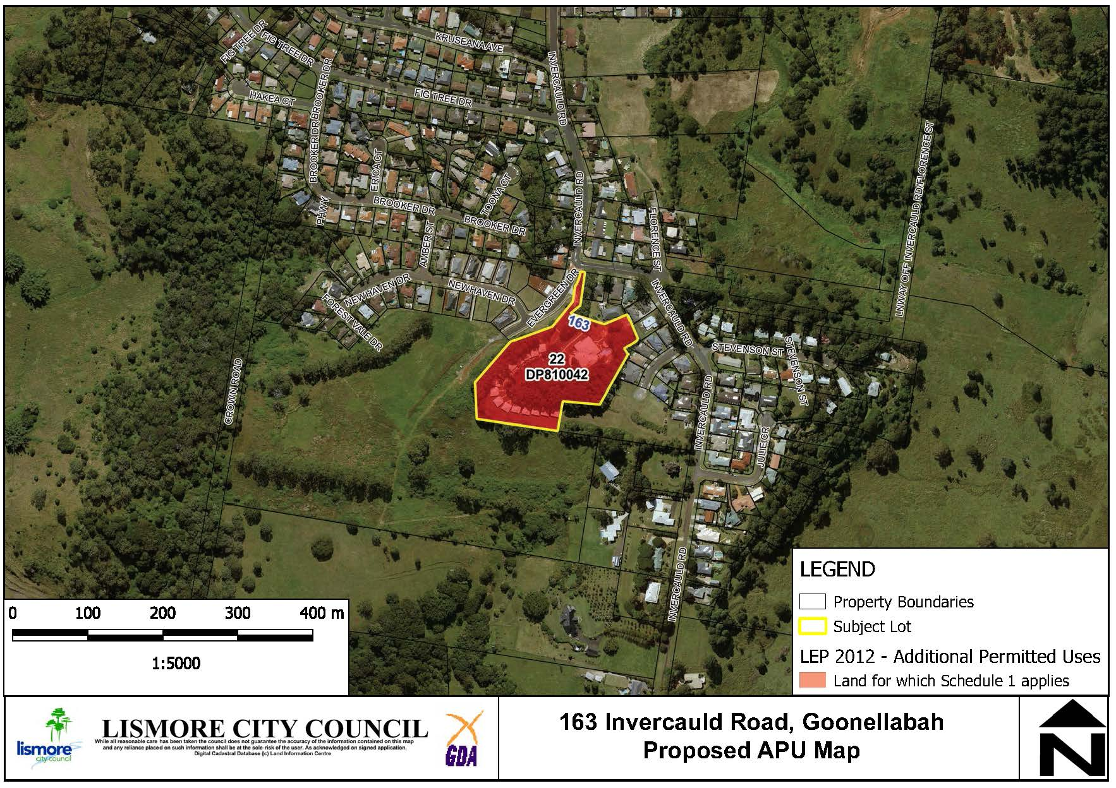

**Figure 5: Proposed APU LEP Map – 163 Invercauld Road, Goonellabah.**

Comments

Finance

N/A

Other staff comments

Council’s specialist staff have assessed the Planning Proposal as required and their comments are incorporated into the relevant sections of this report.

Public consultation

Council will carry out consultation with the community following Gateway Determination. For the purposes of public notification, Council considers that a fourteen (14) day public exhibition period is appropriate.

Notification of the exhibited Planning Proposal will include:

* A newspaper advertisement (Local Matters) that circulates in the area affected by the Planning Proposal.
* The website of Lismore City Council and the Department of Planning and Environment.
* Letter to adjoining landholders.

The written notice will:

* Provide a brief description of the objectives or intended outcomes of the Planning Proposal.
* Indicate the land that is the subject of the Planning Proposal.
* State where and when the Planning Proposal can be inspected.
* Provide detail that will enable members of the community to make a submission.

Exhibition Material:

* The Planning Proposal, in the form approved for community consultation by the Director General of the Department of Planning, Industry and Environment.
* The Gateway Determination.
* Any studies required as part of the Planning Proposal.

The Gateway Determination will confirm the public consultation requirements.

LEP delegations

Council resolved at its ordinary meeting of 11 December 2012 to accept the delegations which enable it to process the final stages of a planning proposal (LEP amendment). The delegations only extend to minor and routine LEPs. Delegations will be confirmed as part of the Gateway determination.

Conclusion

A preliminary assessment of the Planning Proposal and a constraints analysis of the subject site has not revealed any impediments to the approval of the proposed Schedule 1 Amendment to the Lismore LEP 2012 to identify an additional use (function centre) to be permitted. The Planning Proposal is generally consistent with relevant State Environmental Planning Policies and s9.1 Ministerial Directions and any inconsistencies can be justified. There is sufficient information to enable Council to support the Planning Proposal and forward it to the Department of Planning, industry and Environment for a Gateway Determination.

*Do not delete this line*

## Attachment/s

|  |  |  |
| --- | --- | --- |
| 1. | Planning Proposal 163 Invercauld Road, Goonellabah | (Over 7 pages) |